# LockMe Digital Locker

Description: LockMe.com is a digital locker where users can save their sensitive information and can retrieve from anywhere and everywhere.

TechStack: Java,File Handling and data structures.

Architecture Diagram:

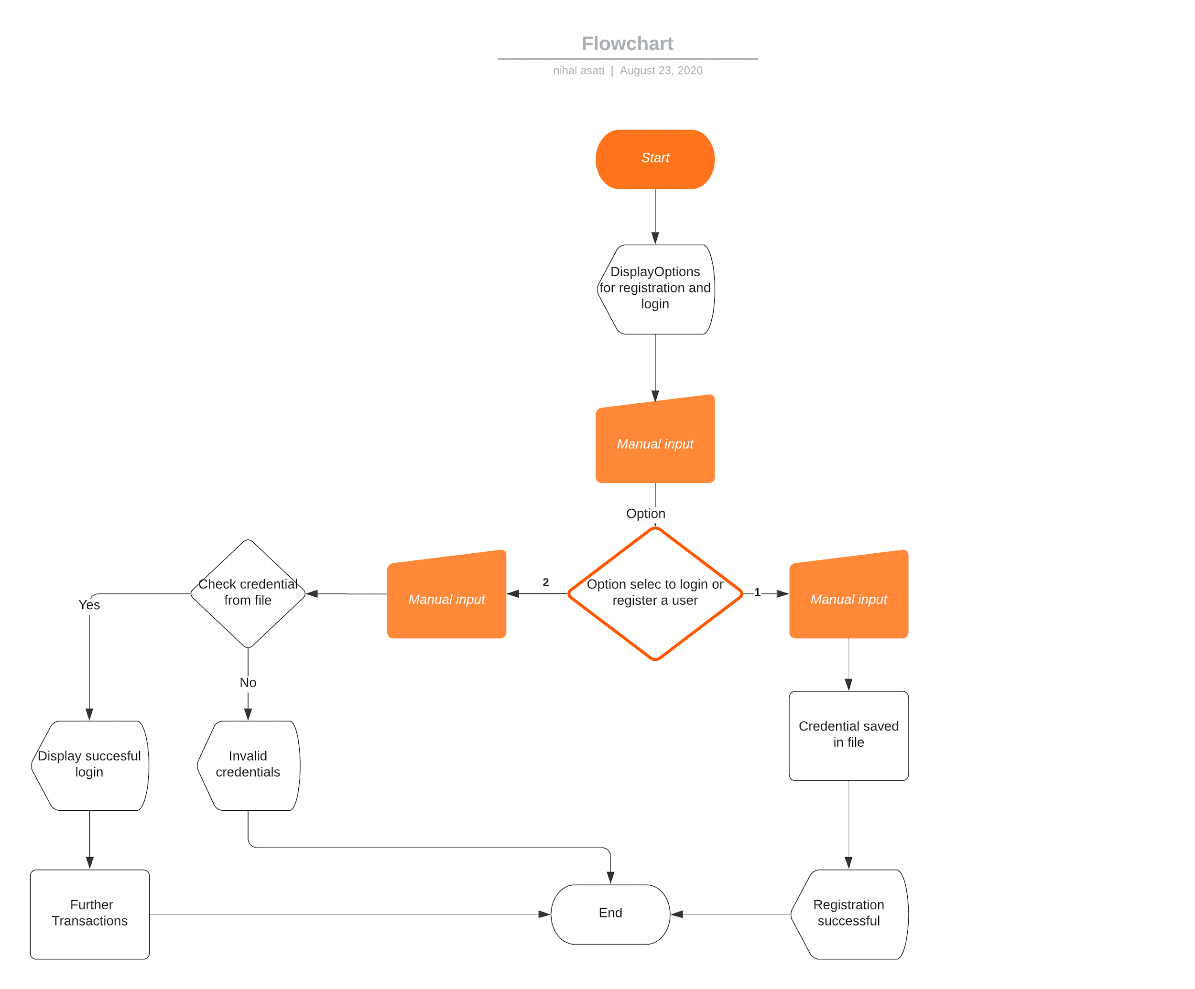

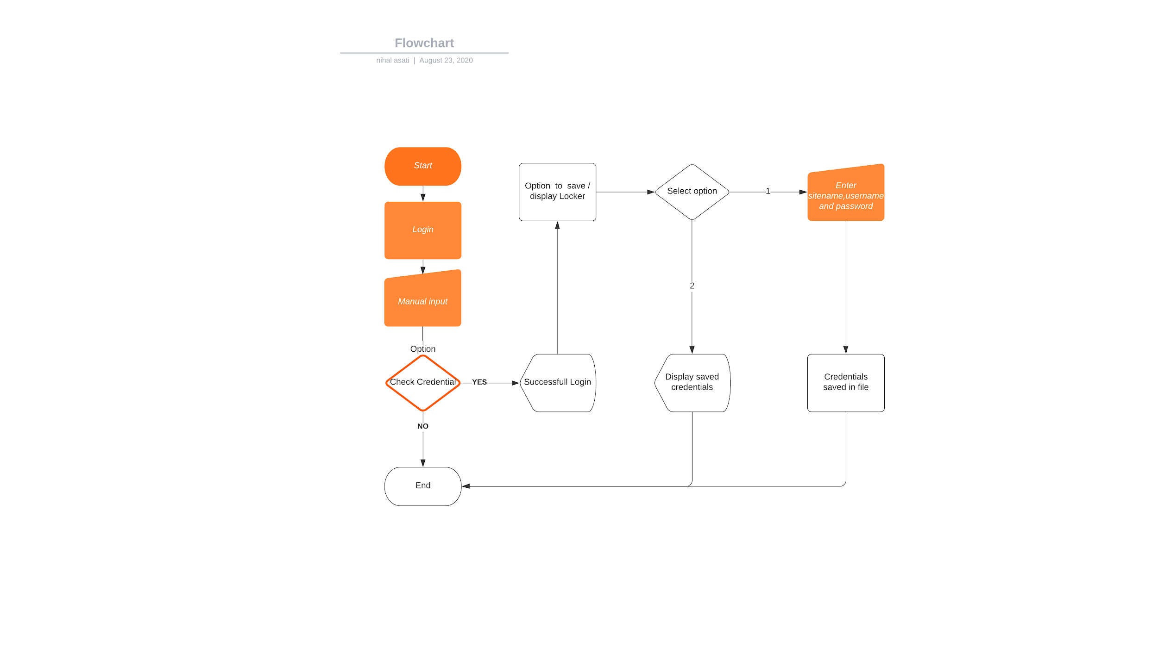

Project User stories ScreenShot:

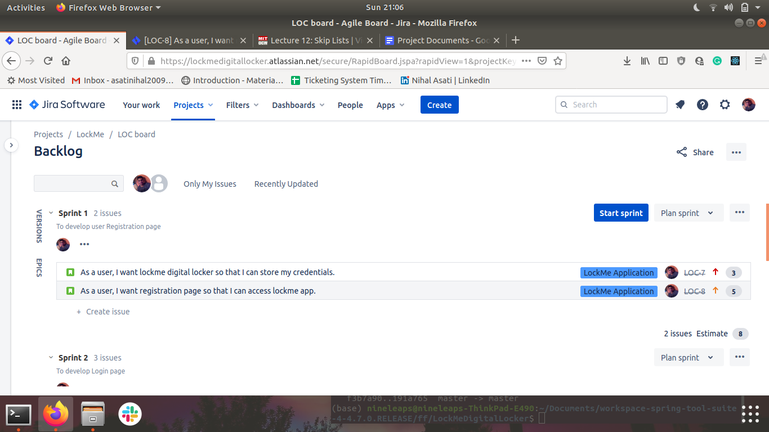

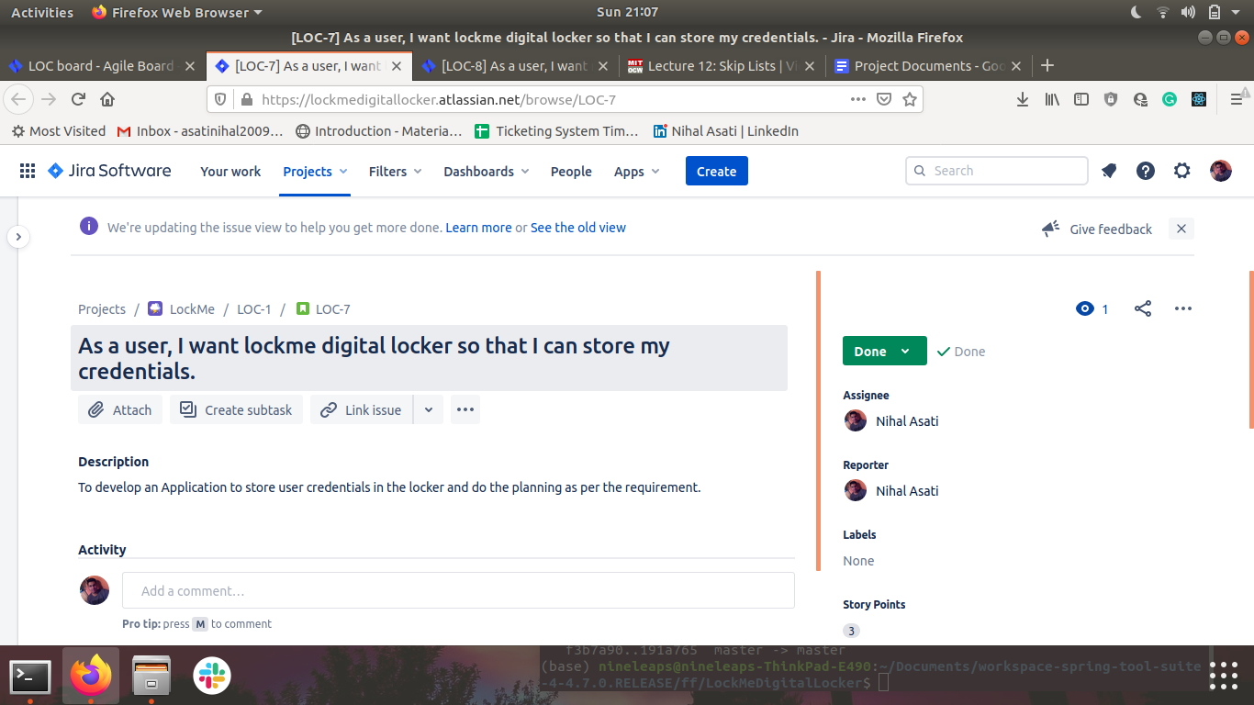

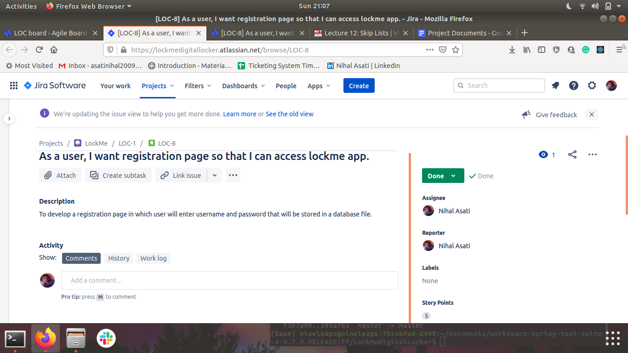

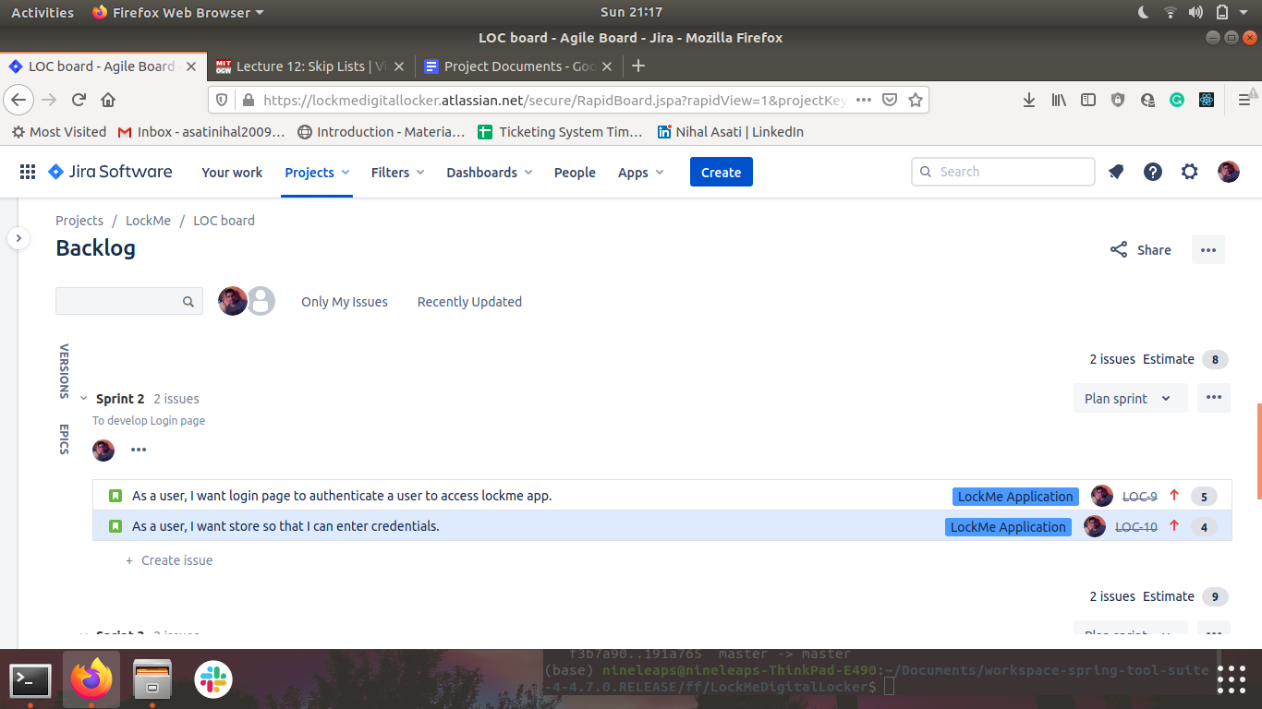

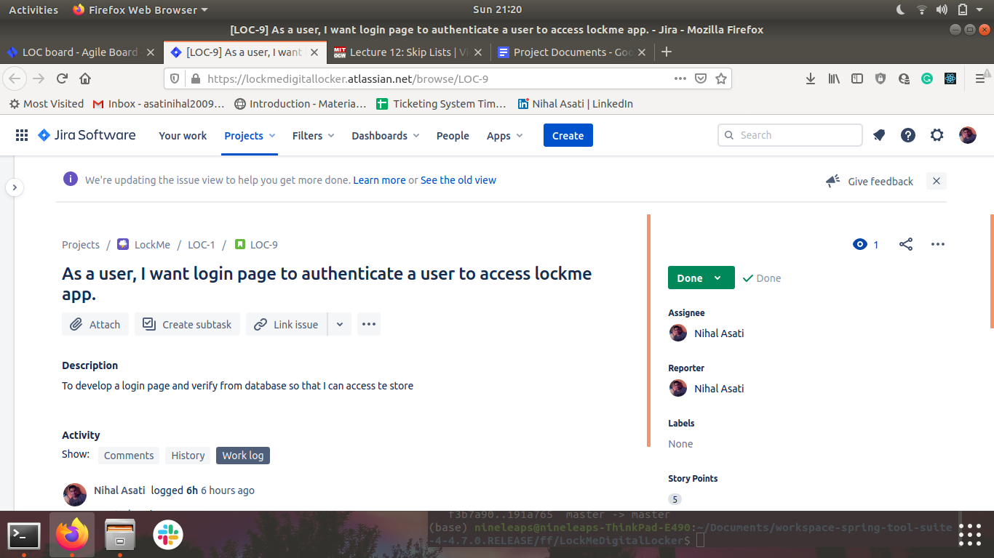

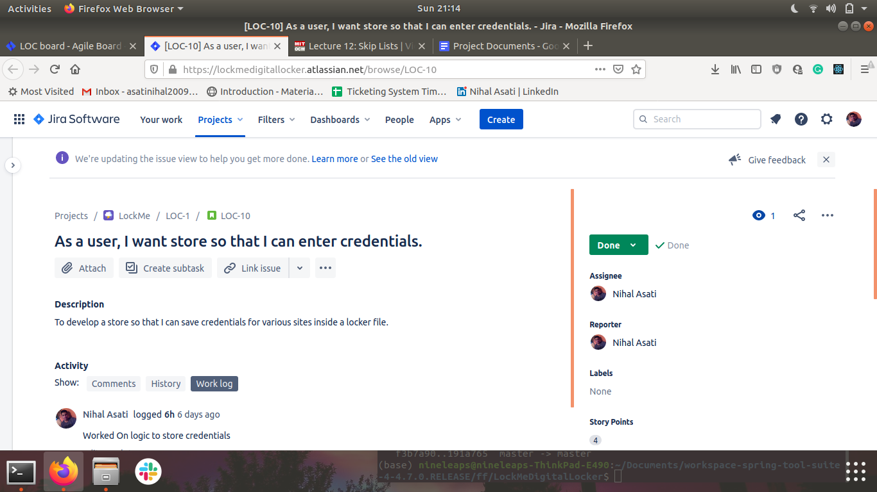

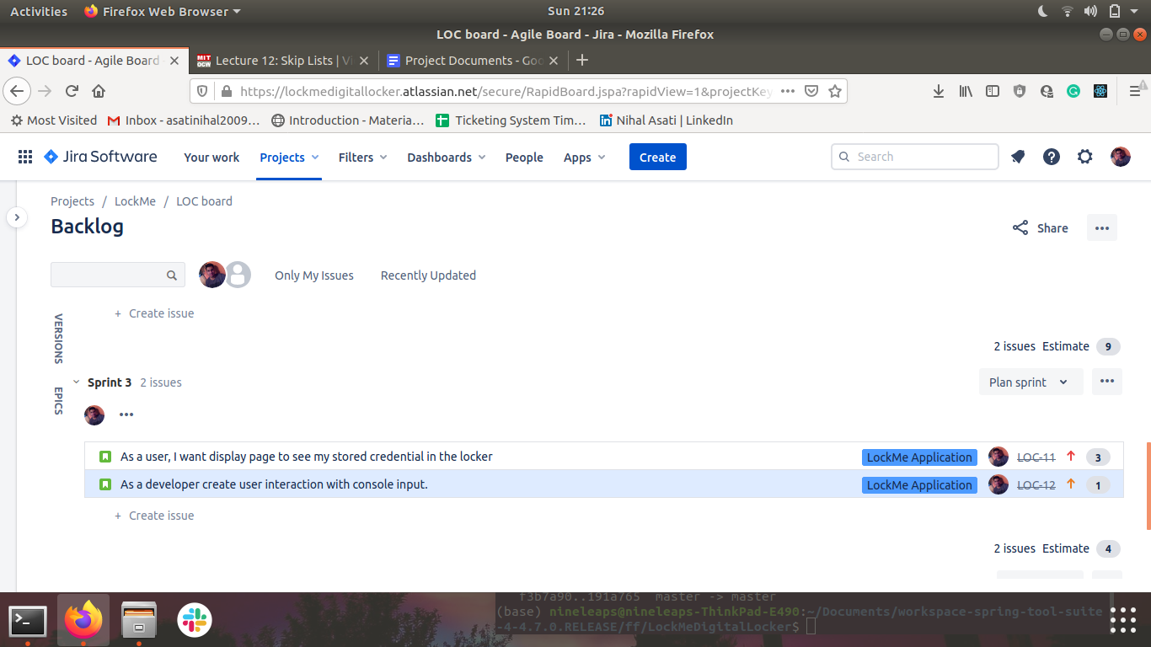

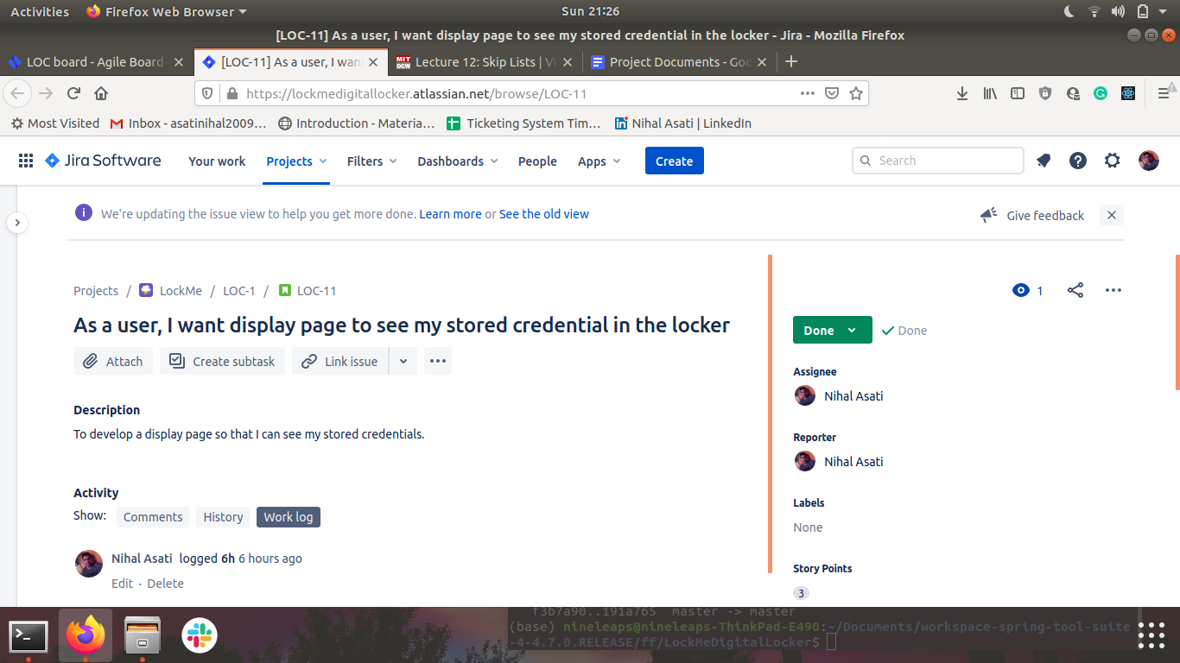

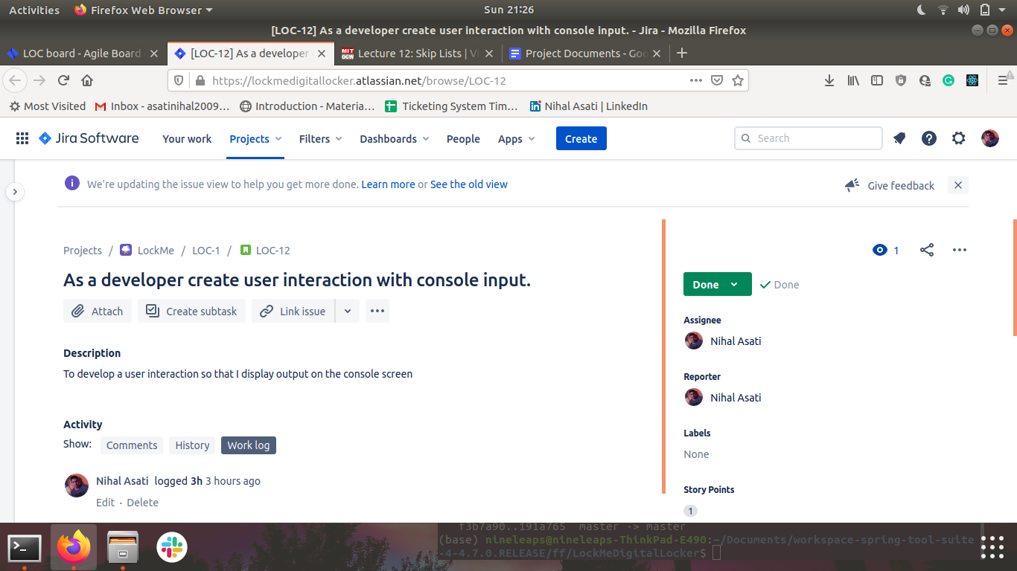

Project Git Repository: https://github.com/AsatiNihal2009/LockMeDigitalLocker

Project Source Code:

package com.simplilearn.lockMe;

import java.io.BufferedReader;

import java.io.File;

import java.io.FileNotFoundException;

import java.io.FileReader;

import java.io.FileWriter;

import java.io.PrintWriter;

import java.io.IOException;

import java.io.InputStreamReader;

import com.simplilearn.lockMe.Entity.Credentials;

import com.simplilearn.lockMe.Entity.User;

public class LockMe {

private static BufferedReader br = new BufferedReader(new InputStreamReader(System.in));

private static PrintWriter fileOutput = null;

public static void main(String[] args) {

System.out.println("/****************Welcome TO LockMe*****************/\n\n");

System.out.println("Press:\n 1 For Registration \n 2 For Login");

try {

int input = Integer.parseInt(br.readLine());

switch (input) {

case 1:

userRegistration();

break;

case 2:

Login();

break;

default:

System.out.println("Input Correct Value Defined Above next Time");

}

} catch (NumberFormatException | IOException f) {

System.out.println("Please Enter Correct Values next Time");

}

}

private static void Login() {

File file = new File("database.txt");

if (file.exists()) {

System.out.println("/***Login***/\nEnter Username ");

try {

String username = br.readLine();

System.out.println("Enter Password");

String password = br.readLine();

BufferedReader br = new BufferedReader(new FileReader(file));

String s;

while ((s = br.readLine()) != null) {

if (username.matches(s)) {

if (password.matches(br.readLine())) {

System.out.println("Login Successful:200 OK");

storeCredentials();

br.close();

return;

}

}

}

System.out.println("Invalid Attempt");

br.close();

} catch (IOException e) {

System.out.println("File Input Error");

}

} else {

System.out.println("File Not found");

return;

}

}

private static void storeCredentials() {

System.out.println("/***Locker***/\nPress:\n 1 Enter Credentials \n 2 Fetch Stored Credentials");

try {

int input = Integer.parseInt(br.readLine());

switch (input) {

case 1:

inputCredentials();

break;

case 2:

fetchCredentials();

default:

System.out.println("");

break;

}

} catch (NumberFormatException | IOException e) {

System.out.println("Please enter correct values");

return;

}

}

private static void fetchCredentials() {

File file = new File("locker-file.txt");

if (file.exists()) {

try {

BufferedReader br = new BufferedReader(new FileReader(file));

String s;

while ((s = br.readLine()) != null) {

System.out.println(s);

}

br.close();

} catch (IOException e) {

System.out.println("Error File Opening");

return;

}

}else {

System.out.println("File Not found");

return;

}

return;

}

private static void inputCredentials() {

System.out.println("Enter Details into Locker");

Credentials credential = new Credentials();

try {

File file = new File("locker-file.txt");

if (file.exists()) {

fileOutput = new PrintWriter(new FileWriter(file));

System.out.println("Enter site Name");

credential.setSiteName(br.readLine());

fileOutput.println(credential.getSiteName());

System.out.println("Enter Username");

credential.setUsername(br.readLine());

fileOutput.println(credential.getUsername());

System.out.println("Enter Password");

credential.setPassword(br.readLine());

fileOutput.println(credential.getPassword());

System.out.println("Credentials entered successfully");

return;

} else {

throw new FileNotFoundException("No file exist");

}

} catch (IOException e) {

System.out.println("Error Opening File");

return;

} finally {

fileOutput.close();

}

}

private static void userRegistration() {

File file = new File("database.txt");

User u = new User();

try {

if (file.exists()) {

fileOutput = new PrintWriter(new FileWriter(file));

System.out.println("/***User Registration***/\nEnter Username ");

u.setUsername(br.readLine());

System.out.println("Enter Password");

u.setPassword(br.readLine());

fileOutput.println(u.getUsername());

fileOutput.println(u.getPassword());

System.out.println("Registration Successful");

} else {

throw new FileNotFoundException("File Doesnot exist");

}

} catch (IOException e) {

System.out.println("File Input Error");

return;

} finally {

fileOutput.close();

}

}

}

4.How to run project:

4.1. clone project:clone git:https://github.com/AsatiNihal2009/LockMeDigitalLocker.git

4.2. Open src->com->simplilearn->lockme-> main.java -> right click -> run as java application.

Output ScreenShot:

